1.2 Task Management
MEL15-Avengers Organisation's Assignment project board on GitHub Projects was used to handle task management of the Moonlight WMS project.
GitHub Project 4 link:
https://github.com/orgs/MEL15-Avengers/projects/4
https://github.com/orgs/MEL15-Avengers/projects/9
Besides informal discussion, a project board was employed by the team to arrange tasks, follow progress, and record things to be completed.The leading step of task management involved team task formation. During the team conference, the main features of the Moonlight WMS system were discussed and the work was fragmented into distinct task areas Because of this. Linking each task with a particular system module ensured that every member had a well-defined task area. that this situation helped the avoidance of confusions since everyone understood which part of the system they would be working on.The project tasks were structured by the system's core modules like authentication dashboard product catalogue inventory stock movement alerts search, AI support, admin and security deployment database setup, and hosting.
Thanks to this arrangement, the team was able to split up their work because they could dedicate themselves to the development of their own module but, at the same time, contribute to the final product.Task workflow was handled with GitHub Project.
The team could monitor tasks by their stages using a project board i.e. planned, in progress, under review, or done. It turned out very helpful to get an overview of which parts of the system have already been completed and which parts require further work.The use of GitHub Projects led to a higher level of openness within the team.

Without the need to individually request updates, members were able to simply take a look at the project board to see the work progress of different modules. As a result, the team was better able to keep pace with the project timeline and the progress recording was more systematic.
This task management approach helped the team manage the project in a structured way. GitHub Project provided the formal tracking system, while WhatsApp supported quick communication when issues or blockers appeared. By combining both tools, the team was able to plan tasks, monitor progress, solve problems, and complete the Moonlight WMS project more effectively.
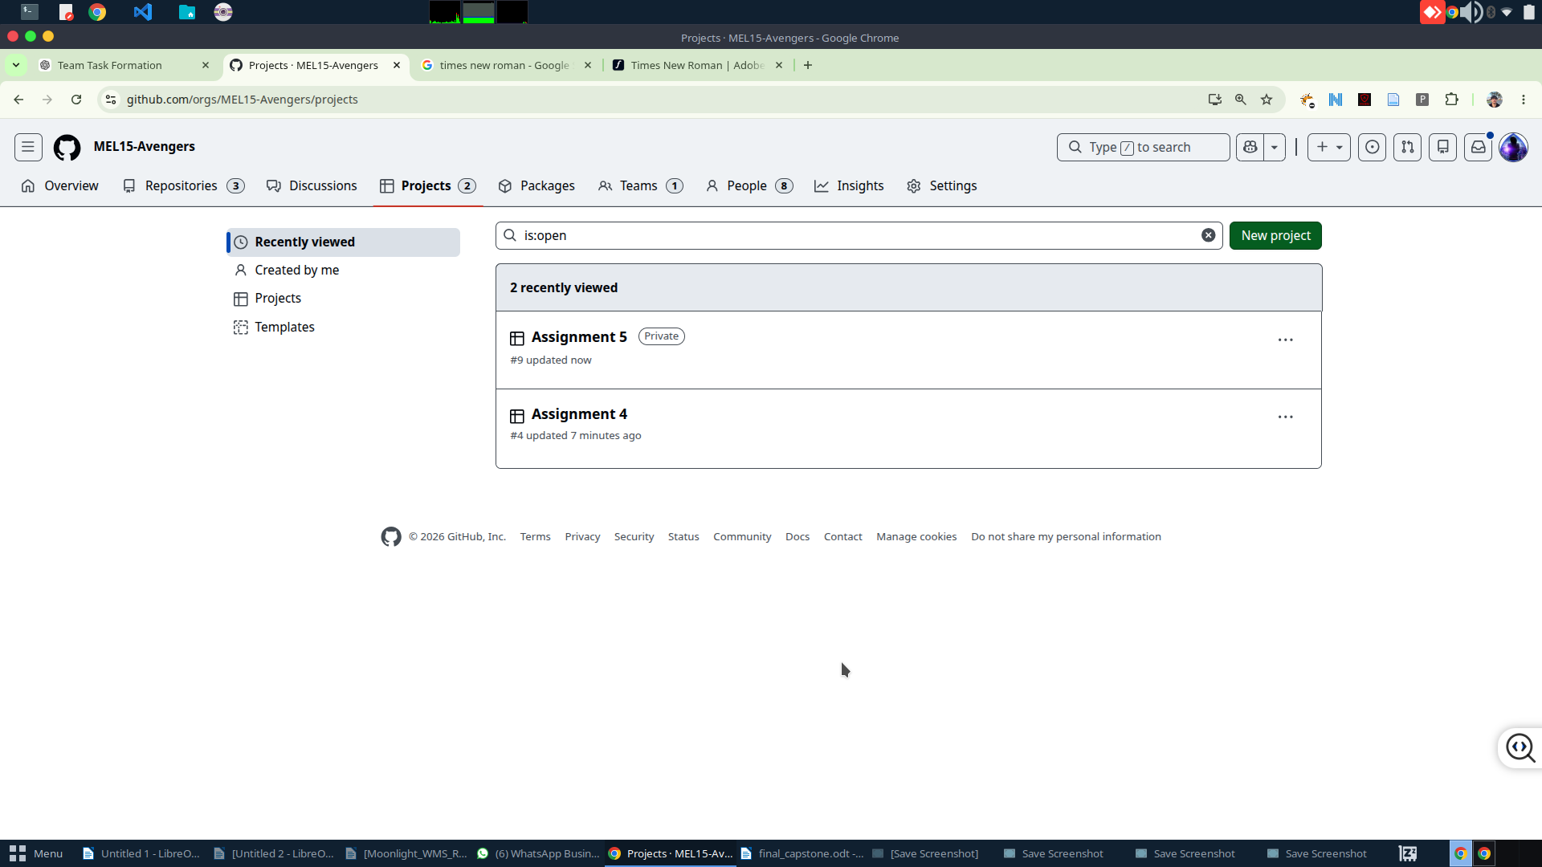Figure 3: GitHub Project
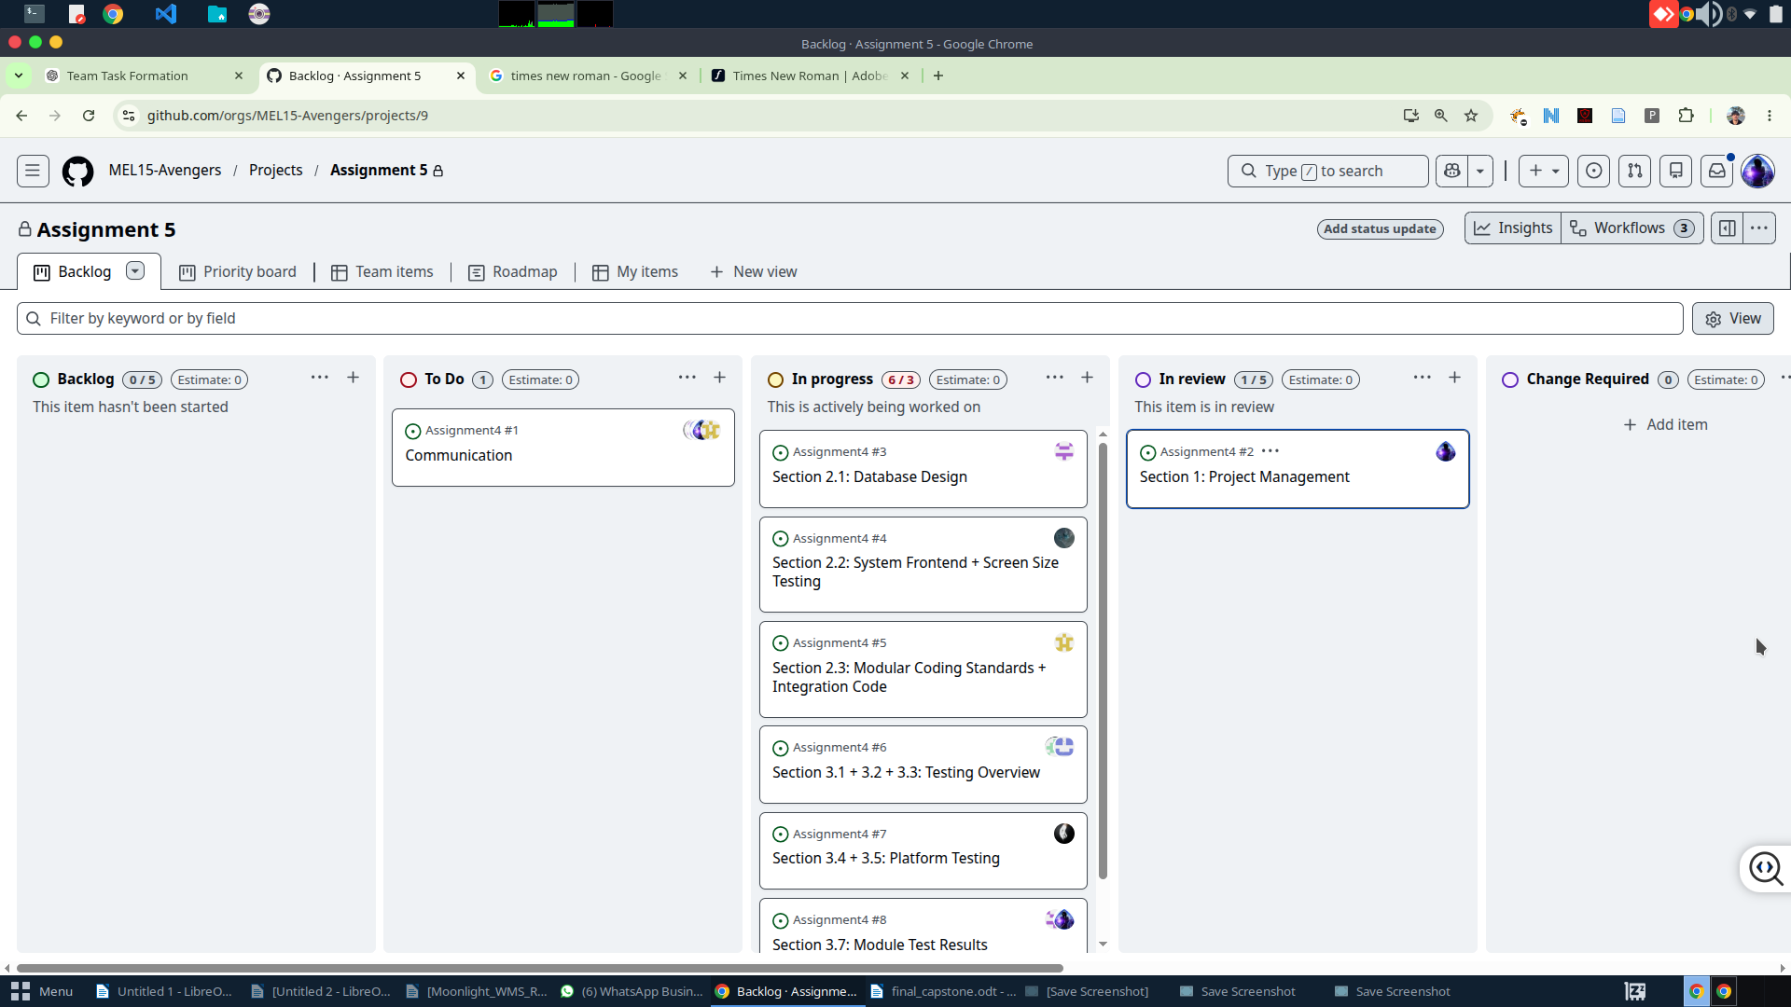Figure 4: GitHub Project task cards showing module-based task management

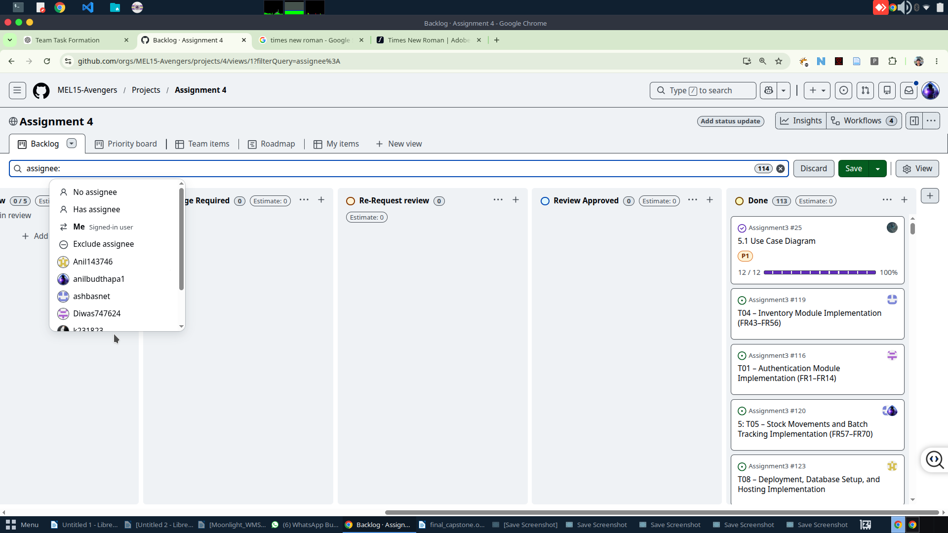Figure 5: GitHub Project columns showing task progress such as planned, in progress, review, and completed

